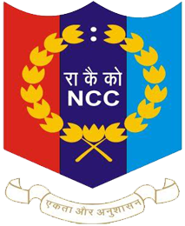
About NCC
National cadet Corps (NCC) at Ch. Bansi Lal Govt. College Loharu (Bhiwani) is sub-unit of 16 Haryana Battalion NCC Narnaul which trains cadets in discipline, leadership, patriotism and social services. NCC is an important part of students’ life and personality development. This NCC encourages the students to participate in Drill and Parade Training, Weapon Training and Firing Practice, Annual Training Camp (ATC), Republic Day and Independence Day Parades, Social Awareness and Cleanliness Drives, Disaster Management, Adventure Activities like Trekking and Camps. NCC cadets of this unit may perform the duty as second line of Indian Armed Force in the need.


Dr Bajrang
CTO NCC
Ch. Bansi Lal Govt. College
Loharu (Bhiwani)

