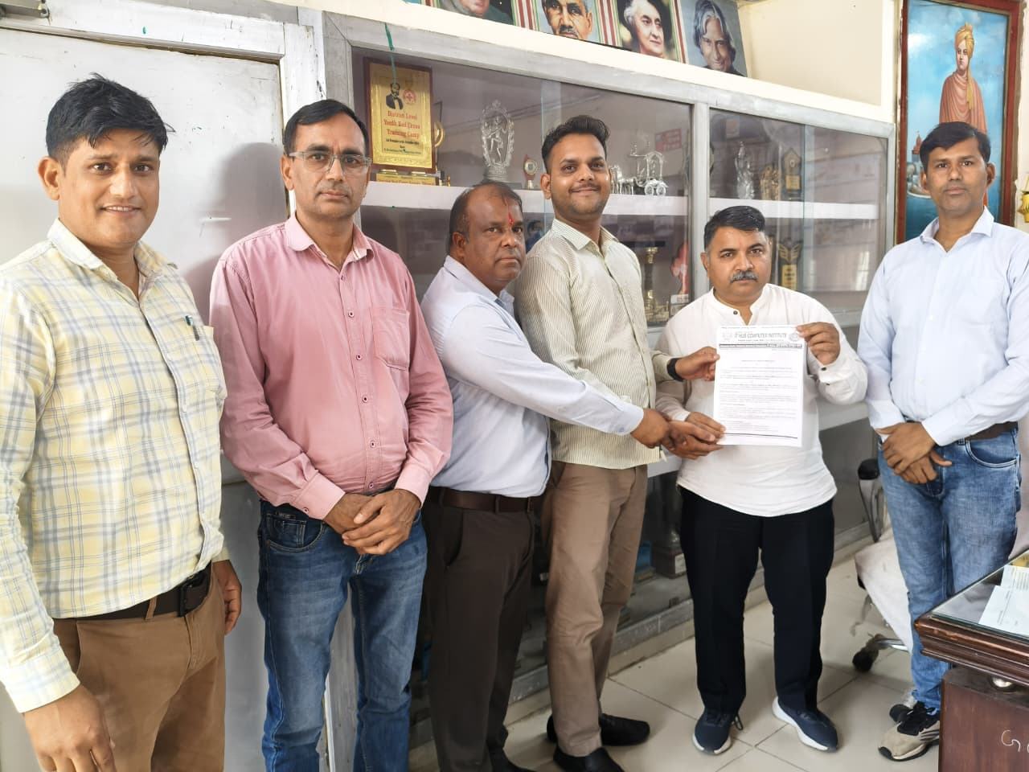
MoU signed between Ch. Bansi Lal Govt. College Loharu and IT Hub Computer Institute Loharu, HKCL authorised Centre promoted by Govt. of Haryana for the mandatory Internship of UG/PG students under NEP
